Unit Test Review: Waves, Sound and the Ear

Waves and Sound
- Draw and label the parts of a longitudinal wave.

- Draw and label the parts of a transverse wave.

- A sound wave is energy that travels through a medium that is caused by what?

- Sound is what kind of wave?

- The material that sounds travels through is called what?

- List the 3 main types of mediums that sound travels through.

- Sound waves with a low amplitude would have this kind of sound? And waves with a high amplitude would have this kind of sound?

- Sound would travel through which medium the fastest?

- A high pitch sound would have what kind of frequency? A low pitch sound would have what kind of frequency?

- On the diagram, which is a high frequency and low frequency?

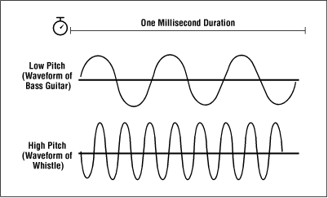
A.

B.
- On the diagram, which is the louder sound and the quieter sound?
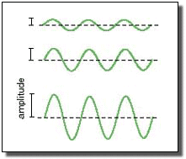

- What unit do we use to measure volume?

- What unit do we use to measure pitch?

The Ear
- Label the diagram of the ear.

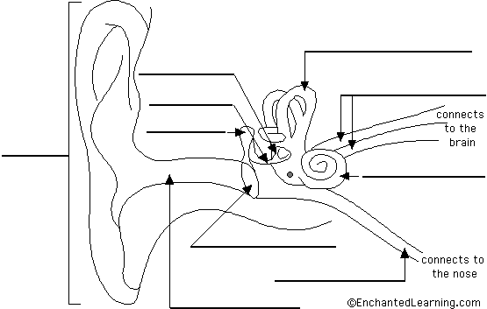

- What is the order that sound travels through our ear?

- The ear is divided into how many sections?

- What are the names of the different sections of the ear?

- What is the function of the pinna?

- Why is your eardrum like a real drum?

- What are the parts of the middle ear and what makes them special?

- What is the importance of the hair cells in the cochlea?

- What is the function of the auditory nerve?

