**Changes of States**

* Matter can change from one state to another when heat\_\_\_\_\_\_\_\_\_\_\_\_ is released or absorbed.
* This is called a change of \_\_\_\_\_\_\_\_\_\_\_\_\_.

C:\Documents and Settings\Geneva Baker\Application Data\Microsoft\Media Catalog\Downloaded Clips\cl0\en00275_.wmf

* The change from the \_\_\_\_\_\_\_\_\_\_\_\_ state to the \_\_\_\_\_\_\_\_\_\_\_\_\_\_\_ state is **melting.**
* The temperature at which a substance changes from a solid to a liquid is called the **\_\_\_\_\_\_\_\_\_\_\_\_\_\_\_\_\_\_\_\_\_ point.**
* Melting is when matter absorbs \_\_\_\_\_\_\_\_\_\_\_\_\_\_\_ energy, and its temperature rises.



* The change from the liquid state to the solid state is called **\_\_\_\_\_\_\_\_\_\_\_\_\_\_\_\_**.
* The temperature at which a substance changes from the liquid state to the solid state is called the \_\_\_\_\_\_\_\_\_\_\_\_\_\_\_\_\_\_\_point.
* \_\_\_\_\_\_\_\_\_\_ is released during freezing.

C:\Documents and Settings\Geneva Baker\Application Data\Microsoft\Media Catalog\Downloaded Clips\cl2d\j0112746.wmf

* The change from a \_\_\_\_\_\_\_\_\_\_\_\_ state to a \_\_\_\_\_\_\_\_\_\_state is known as evaporation.
* The temperature at which a liquid boils is called the **\_\_\_\_\_\_\_\_\_\_\_\_\_\_\_\_\_\_\_ point.** 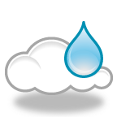
* As a gas cools, its particles slow down. The process of a gas changing to a liquid is called **\_\_\_\_\_\_\_\_\_\_\_\_\_\_\_\_\_\_\_\_\_\_\_\_\_.**
* This process is the opposite of **\_\_\_\_\_\_\_\_\_\_\_\_\_\_\_\_\_\_\_\_\_\_\_\_\_\_\_\_\_\_\_.**

**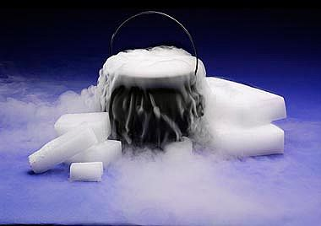**

* Some substances can change from the solid state to the \_\_\_\_\_\_\_\_\_\_ state without ever becoming a liquid.
* This process is known as **\_\_\_\_\_\_\_\_\_\_\_\_\_\_\_\_\_\_\_\_\_.**