Atoms Around Us

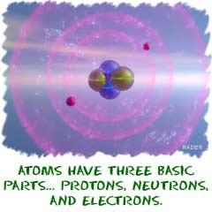
Atoms are building blocks. If you want to create a language, you'll need an alphabet. If you want to build proteins, you will need amino acids. If you want to build molecules, you will need atoms of different elements. Each element is a little bit different from the rest. Those elements are the alphabet in the language of molecules.
Why are we talking about elements? This is the section on atoms. Atoms are the general term used to describe pieces of matter. You are made up of billions and billions of atoms. However, you may only find about 40 elements inside of your body. You would find hydrogen (H) atoms, oxygen (O) atoms, and a bunch of others. Those other atoms are made of the same basic pieces, but they are organized in different ways to make each element unique.

Common Elements
Let's work with that idea for a bit. If you read a book, you will find a bunch of words on a page. Letters make up those words. In English, we only have twenty-six letters, but we can make thousands of words. In chemistry, you are working with around 120 elements, and when you combine them you can make millions of molecules. Molecules are groups of atoms bonded together in the same way that words are groups of letters. An "A" will always be an "A" no matter what word it is in. A sodium (Na) atom will always be a sodium atom no matter what compound it is in. While the atoms may have different masses and organization, they are all built with the same parts. Electrons, protons, and neutrons make the Universe the way it is.
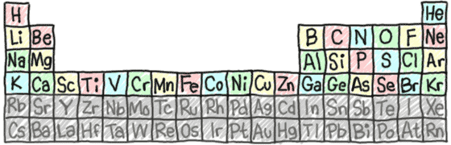
Now we're getting to the heart and soul of the way your universe works. Elements are the building blocks for all matter. We talked about quarks in the atoms section. They are smaller than the main components of an element such as electrons, protons, and neutrons. Only when those parts come together do we have atoms with recognizable traits. Some subatomic particles combine to make an oxygen (O) atom. Others can combine to form a nitrogen (N) atom. It's the elements that are different and unique, even though they are made of the same pieces.
We sometimes use the terms atom and element to mean the same thing. Remember that atom is the general term. Everything is made of atoms. The term element is used to describe atoms with specific characteristics. There are about 120 different elements. You are made up of billions and billions of atoms but you probably won't find more than 40 elements (types of atoms) in your body. Chemists have figured out that over 95% of your body is made up of hydrogen (H), carbon (C), nitrogen, oxygen, phosphorus (P), and calcium (Ca).

